AZ900 Notes

# Chapters

## Chapter 1:

* C 1.9 – Azure CLI
  + Pros:
    - text commands are stable/don’t change
    - cross platform
    - structured/pattern
    - automation
    - log the commands
* 1.10 – Azure Powershell
  + cmdlets (ex. New-AzVm)
  + powershell talks to Azure Resource Manager (ARM) directly
* 1.12 – Cloud Shell
  + accessible through web or mobile
* 1.14 – ARM Templates
  + describes the resource usage (update/delete/create)
  + written in JSON
  + Pros:
    - Idempotent (reusable)
    - source control
    - reuses the template
    - declarative
* 1.15 – Azure Advisor
  + recommendations for security, cost savings, performance, availability, operational excellence

## Chapter 2 – Cloud Concepts

* C 2.2 – language of Cloud Computing (CC)
  + Key Terms:
    - High availability --> Vms can spin up to process reqs
      * don’t own hardware
      * easily replace resources
        + cluster = group of Vms
    - Fault Tolerance --> how Azure ensures 0 downtime
      * resiliency -> less down-time
    - Disaster Recovery
      * recovering from hurricanes, cyber attacks, etc.
      * A plan to recover critical systems
    - Scalability (scenario based)
      * ability of getting resources when traffic is high automatically
      * scale up or down or out
    - Elasticity
      * ability to expand/decrease computing resources
      * enables scaling
    - Agility
      * ability to develop/launch/test software apps
* C. 2.3 – Cost of the Cloud
  + Cap Expenditure --> cost to get fixed resources
    - ex. one time purchase
  + Op Expenditure --> cost to run business/product daily
  + Azure has a **consumption based** pricing
    - pay only for resources used
      * ex. per execution or second
* C. 2.4 – Cloud Service Models
  + 3 Types:
    - Infra-as Service (IaaS)
      * = actual servers
        + quick scaling
        + no ownershop of hardware

ex. Vms, servers, networks

* + - Platform-as Service (PaaS)
      * superset of IaaS, supports Software Dev Cycle
        + **ex**. Middleware, Tools
    - Software-as Service (SaaS)
      * provides a managed service (pay access fee to use the software)
      * built on PaaS
        + ex. Office 365, Azure Apps (SQL managed server)
  + Serverless
    - you don’t have to manage any servers
    - ex. Azure Functions
* Identify CSM

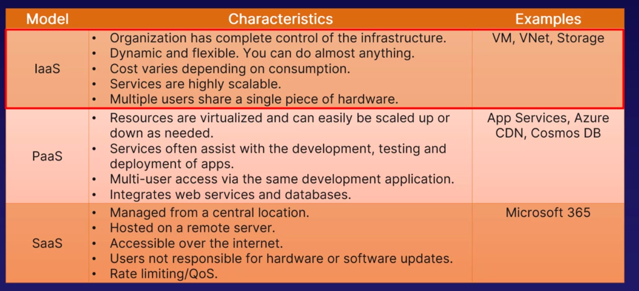

* Shared Responsibility Model
  + between you and MS Azure
* C 2.5 – Azure Marketplace
  + contains SaaS, tools, etc.
    - Pros:
      * less maintence/certified products
      * efficient
      * tech support from MS
* C 2.6 – Cloud Arch Models
  + 3 Types:
    - Private (own cloud)
      * pros:
        + complete control of infra
        + security/privacy
      * Cons:
        + org is responsible for who cloud
    - Public
      * ex. Azure, AWS
        + Pros:

no need to purchase own hardware

low monthly fee

* + - * + Cons:

no control of features

updates

* + - Hybrid (mixed of Private/Public)
      * Pro:
        + avoid disruptions/outages
        + adhere to laws
        + reduces CapEx
      * Cons:
        + complex infra

## Chapter 3 – Azure Architecture

* C 3.2
  + **Regions** --> set/group of data centres close together, connected by fiber cables
    - latency = time for data to travel
    - **3 criteria** on choosing a region
      * location of your users
      * features (not all availability in all regions)
      * pricing of region
    - Paired regions (ex. USCN, USEA)
      * reduces impact of outages and planned updates
      * geo-redundant storage
  + **Availability Zone**
    - unique physical locations in a region
    - minimum 3 zones in 1 Region
    - each zone has own power, cooling, networks
    - replicates data across paired zones
* C3.3 – Resource Group (RGP)
  + RGP
    - all resources must be kept in a group
    - resources within the group can be from diff regions
    - RGP has it’s own access control
    - RGP has it’s own region for metadata
  + ARM
    - single entry point for all resources and interactions with them
      * Pros:
        + group resource handling
        + consistent handling of all resources
        + define dependence
        + access control in ARM
        + Tag each resource

## Chapter 4 – Compute

* C 2.2 – VMs
  + “computer” or server (no physical hardware) you have excusively
    - it is IaaS
    - Azure has tooling to manage VMs
    - Blueprints can be used to ensure VMs are compliant
  + Pricing
    - hourly rate of VM use.
  + Use Cases
    - pros:
      * control of VM
      * install specific apps on it
    - cons:
      * maintenance is annoying
  + Key Points:
    - “computer” you have exclusive access to
    - you don’t control hardware
    - IaaS offering
    - pricing is based on RAM use
    - azure has tools to control VMs
* C4.4 – Scale Sets
  + It lets you manage group of identical, load balanced VMs
    - *Scale Set = the group of backup identical VMs*
    - *Baseline VM = the VM you are copying*
  + Azure adds/removes a new identical VMs when your VM is reaching 100% resource usage
    - ensures availability and scaling
  + **Pros**:
    - easy to manage multiple identical VMs (load balancing)
    - high availability
    - auto scaling (scale out/in)
    - Large Scale manages 1000 VMs
    - no extra costs
* C 4.5 – App Service (PaaS part of Azure Compute)
  + 3 types:
    - Web Apps (ex. Web sites)
      * easy Azure Integration
      * Autoscale + load balancing
    - Web Apps for Containers
      * container are self contained, dependence internal
    - API App
      * connects back-end (connects to other apps programming)
* C4.6 – Azure Container Instances
  + Features:
    - manage app dependencies
    - less overhead
    - increased protability between OS and plaforms
    - efficieny in dev, deploy, maintain
    - consistent usage among Ops Teams
  + ACI
    - service for hosting/running workloads (your app) in a container
    - Containers are created only when needed
* C 4.7 – Kubernetes (AKS)
  + container orchestration system (tracks features/components) to configure container correctly
    - auto deployment of containers based on need
    - auto scaling
  + Pros:
    - allow replication of container architecture (resuse the template)
    - contains all Azure ServicesTools
    - Global reach
  + Container Registry (ACR)
    - tracks container images
    - manages artifacts for containers
* C4.8 – Virtual Desktop (VD)
  + Pros:
    - Concurrency (users use same VM instance)
    - security of data
    - accessible
* C 4.9 – Functions
  + single action caused by a trigger
    - called or invoked in a URL
  + runs on a VM (but is server-less)
  + Pros:
    - only runs when needed (and only once before ending)
    - saves money
    - resilient (won’t affect other function instances)
* Summary

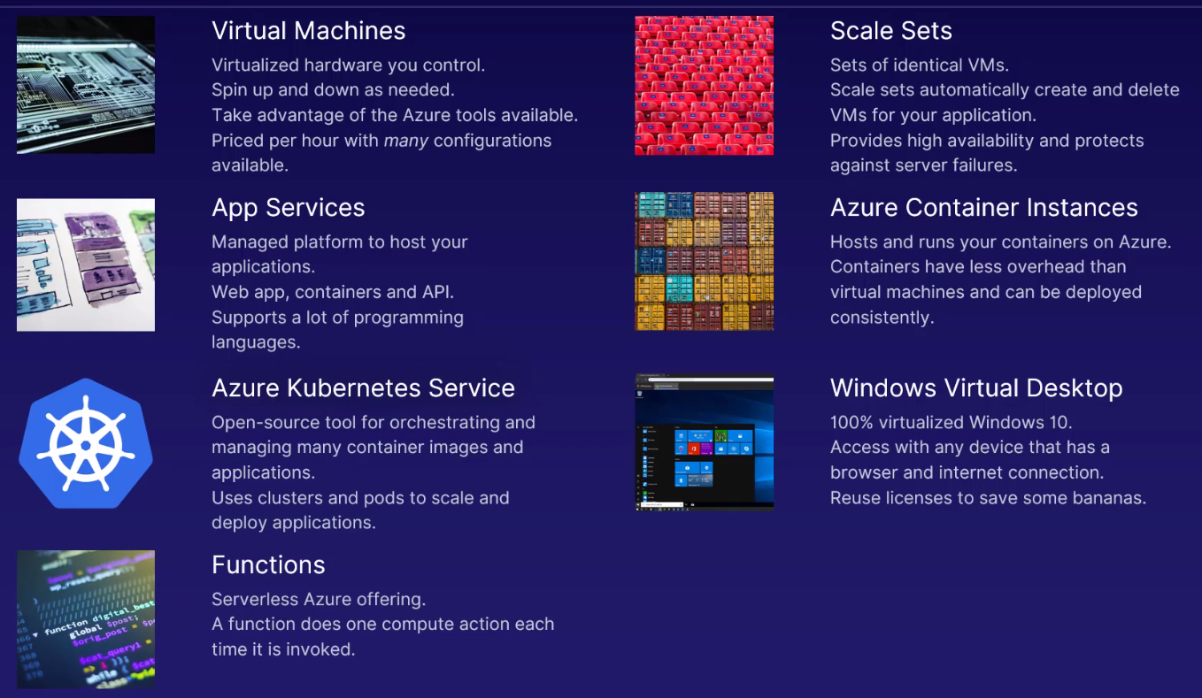

## Chapter 5 – Networking

* C 5.2 – Vnets
  + Ip Address = unique ID for computer
  + Address Space (range of IP address)
  + **Subnets** -> divisions of ip addresses **IN** Vnet
    - **Pros**:
      * group resources together
      * address allocation
      * subnet security is individualized (NSG)
    - * subnets are same region as region and subscription
    - **Pros of Cloud**:
      * Scaling (inc or dec Vnets)
      * high availability
      * Isolate resources through Vnets
    - **Peering of Vnets** = connect VNETS
      * Pros:
        + low latency, high bandwidth connection
        + links separate Vnets
        + data transfering between subs and regions
* C 5.4 – Load Balancer (NLB)
  + NLB captures and manages inbound traffic based on rules/health probes through NLB’s front and backend
  + **Functions**:
    - balance incoming internet traffic
    - balance internal networks
    - forward traffic to specific port/machine
    - control outbound connectivity to backend VMs.
* C 5.5 – VPN Gateway (a specific Vnet gateway)
  + It connects Vnet and On-Prem networks
    - made of 2 or more VMs in the Subnet Gateway
    - secures hybrid cloud architecture
    - allows for sending encrypted data
  + **3 components**: (“Site-to-Site connection”)
    - VPN Gateway has its own public IP
    - Tunnel (secure)
    - On-prem network with own gateway
* C 5.6 – App Gateway
  + Specific Routing:
    - It allows for the redirection of HTTP requests based upon:
      * data format
      * URI address
      * Host header (req. Data)
    - ...to a specific VM
  + **Pros**:
    - Scaling of App Gateway up or down-time
    - End to end encryption
    - Zone redundancy (multiple availability zones)
    - Use same app gateway for up to 100 websites
* C 5.7 – Content Delivery Network (CDN)
  + distributed network of servers that deliver web content close to users
    - CDN’s grab data from nearby servers and only grab from orig. Server if data is unavailable
      * edge nodes = closest to user servers
  + Pros:
    - better performance
    - scaling of traffic + protect your backend server
    - distribute traffic so edge nodes are targeted instead of origin server
  + Terms:
    - Cache = temp copies of files
      * placed close to user
    - Origin server = orig. Location of your web app
* C 5.8 – ExpressRoute (ER)
  + doesn’t go over public internet
    - more security and faster
  + connects On-Prem to Azure Cloud
* Summary

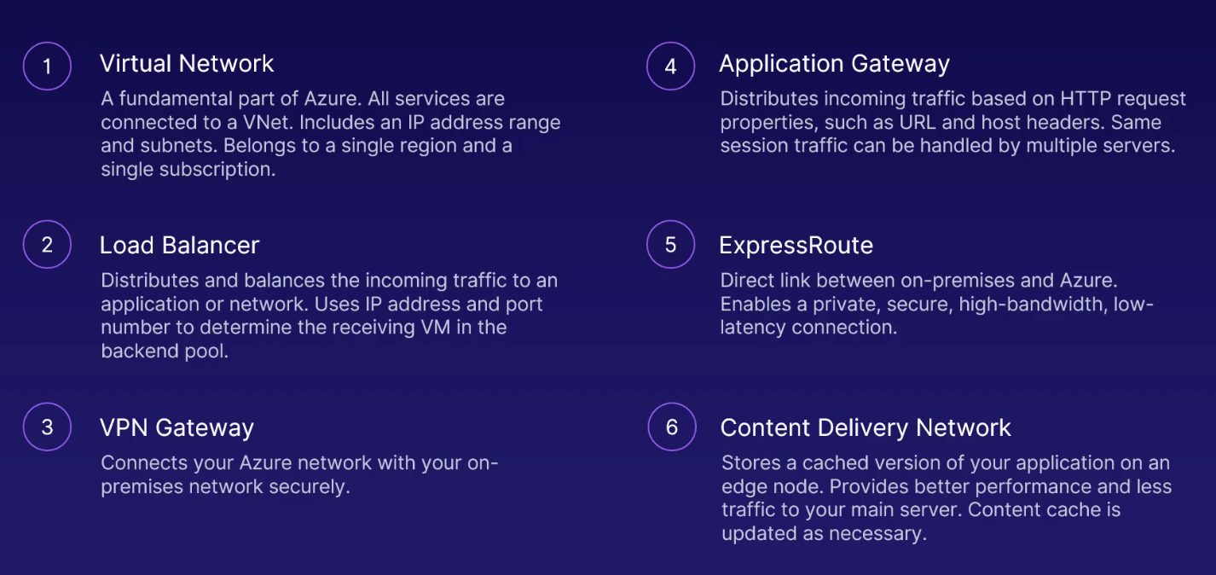

## Chapter 6 – Azure Storage

* Storage Account = unique Azure namespace (own web address) -> must be unique
  + Each chapter is a type of Azure Storage
* C 6.2 – Blob (Binary large object)
  + They are stored in containers within SA
    - Functions:
      * store images
      * any type of files
      * streaming content
      * log files
      * archiving data
    - 3 Types of Blobs
      * Block -> used for handling large amounts of data very effectively.
      * Append -> appending new data to existing content, rather than replacing it.
        + ex. (for logging data)
      * Page (ex. Virtual HDD) -> random read/write operations.
        + ex. sticky notes
    - 3 Pricing Tiers:
      * Hot (for Frequently accessed files)
        + high cost and for low access times of files
      * Cold (Temp files (30 days))
        + lower cost for storage + higher access times
      * Archive
        + cheapest and highest access times
* C 6.3 – Disk
  + Managed Disk (attach to VM)
    - Azure will manage its backup and uptime
    - Azyre guarentees size
  + Disk Types:
    - HDD (low cost)
      * ex. for backups
    - Std. SSD
      * usually for PROD
      * high reliability, scalability and latency
    - Premium SSD
      * super fast, performance
        + ex, Critical workloads
    - Ultra Disk
      * highest tier
* C 6.4 – File storage
  + Allows for mitigation of on-prem file storing and sharing
  + Benefits:
    - Sharing of data across machines, and provides access to on-prem infra
    - Azure manages hardware and OS
    - Resilient to outages
  + Functions
    - Files can be used to supplement or replace on-prem storage
    - Total transfer of on-prem files to Azure cloud
* C 6.5 – Archive storage
  + lowest price tier for Azure Storage
    - helps to free up your storage
    - very secure!
    - Archive storage = blob storage
* Summary

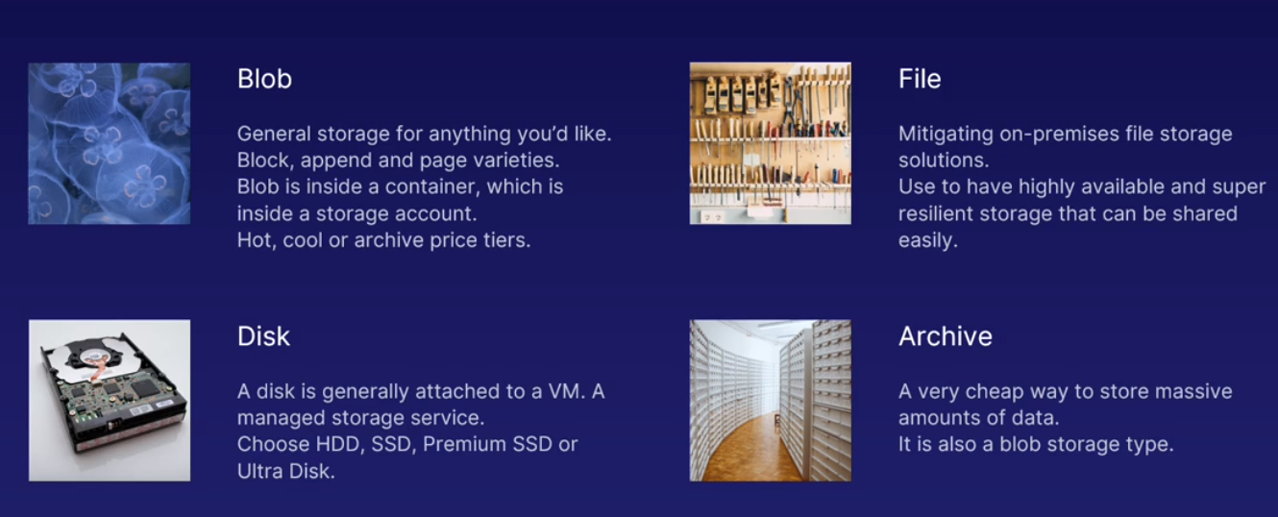

## Chapter 7 – Databases

* C 7.2 – CosmosDB
  + Features
    - Synchronization of data
      * Global access across multiple regions
      * Easy to expand into more regions with data synced
      * Continuous synch.
    - Single-digit latency across all regions
    - Scalability
      * automated scaling.
      * infinite resources to support users
      * lowest price (scaled through usage)
    - Connectivity
      * Devs can connect to Cosmos through SDKs and APIs
      * Language agnostic
      * supports multiple data-platforms integration (ex. SQL, MongoDB)
  + Cons:
    - can be very expensive as Cosmos scales up.
* C 7.3 – Azure SQL
  + Azure will manage hardware and IaaS
  + Seamlessly migrate on-prem SQL to Azure SQL
    - cost saving
    - lower cost-ownership
  + Azure SQL uses ML to suggest:
    - how to optimize performance
    - warnings of degradation
  + Benefits
    - scalability and availability
    - massive space
    - security
  + Azure SQL
    - traditional
  + Azure SQL Managed Instances
    - bridges gap for On-Prem vs. Azure
* Azure DB for MySQL
  + Open source
  + Relational DB
  + Advantages
    - Platform-as a Service
    - Dev focus (less managing servers/networks)
    - choice of language
    - high availability
    - security features
    - cloud PaaS features (patching, backups, monitoring)
  + Functions
    - Web Apps
    - E-Commerce
    - Mobile Apps
    - Dig. Marketing
    - Fin Management
    - Gaming
* C. 7.5 – PostgresSQL
  + Open-source relational
  + Functions
    - Extensions
    - Choice of language
    - Horizontal scaling
    - Perf. Recommendations based on usage
    - Fully Managed
  + Use Cases: (Financial Apps, Gov’t, Manufacturing)
* C. 7.6 – DB Migration Services (DMS) – On-Prem. to Azure
  + Single Tool to migrate
    - Well Documented and Detailed Guides
* Summary
  + 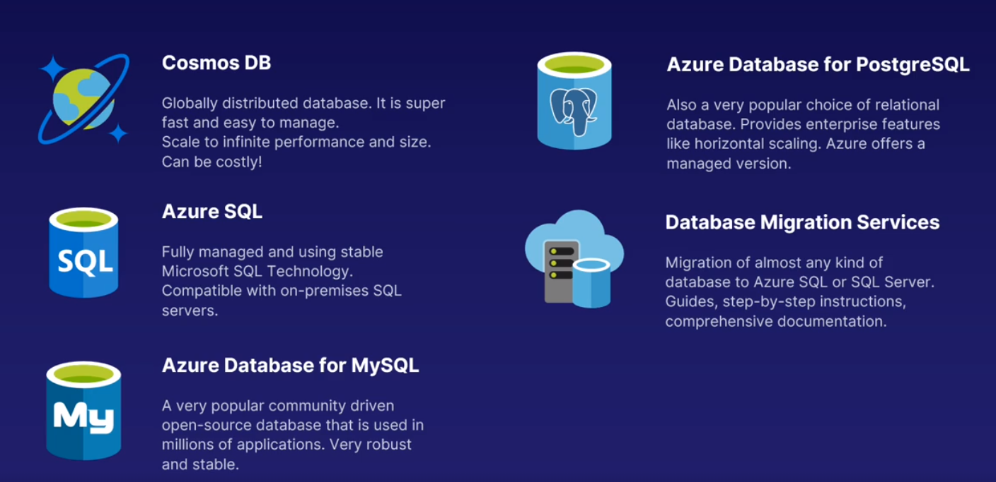kk

## Chapter 8 – Authentication/Authorization (IAM)

* C 8. 2 – Identity Services
  + Access Management
    - Authenticate
      * confirming you.
    - Authorized
      * what do you have access to?
* C 8.3 – Azure Active Directory (AAD)
  + AD
    - Designed orig. For traditional use
    - not designed for web initially
  + AAD service
    - mandatory to an azure account
    - first service of every new account
    - not same as AD
  + Tenant (reps org.)
    - First instance of AAD (first account)
    - Each tenant is separate
    - A user can be a member or guest of max 500 Tenants
  + Subscriptions
    - Billing entity
    - Cost separation
    - Payment (resources in sub will stop w/o payment)
  + AAD in Hybrid Cloud
    - can handle both on-prem and cloud
* C 8.4 – MFA
  + 2+ authentication method
    - User/Pass
    - Authentication App
    - Biometrics
* C 8.5 – Single Sign-on
  + ex. FB account to sign in to stuff
  + AAD Seamless Single Sign-On
* Summary
  + 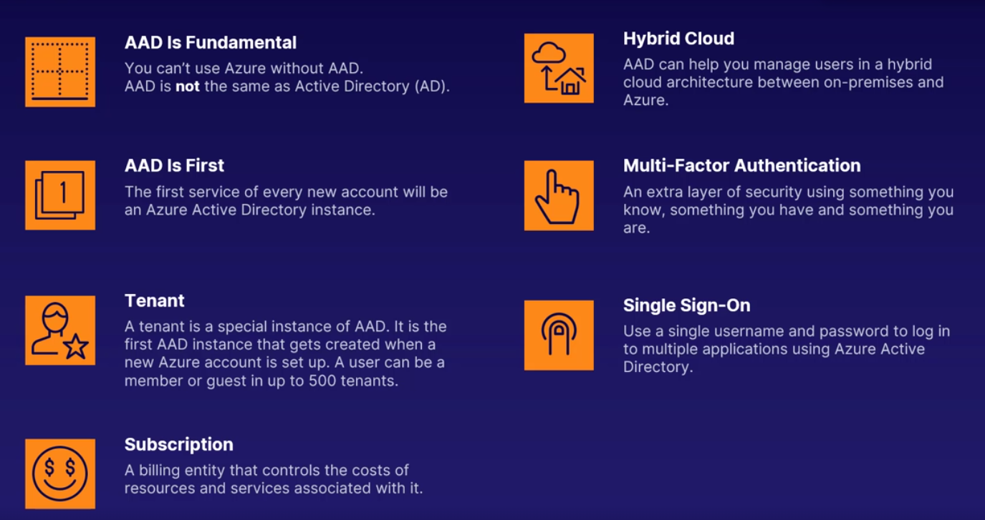

## 

## Chapter 9 – Azure Solutions

* C 9.2 – IoT
  + interconnected computing devices
  + IoT Hub
    - collects **data feeds** from IoT devices
    - ex. Water network
      * view if a specific device fails
    - Functions
      * Managed and secure
      * Ease of deployment
      * PaaS solution
      * Scaling and Authentication
  + IoT Central
    - SaaS
    - No coding needed (dashboards + rules)
    - pre-made connectors
  + Azure Sphere
    - A "turnkey" software AND hardware solution that includes certified hardware designed to connect to a fully managed IoT communication and security suite.
    - requires specific hardware in device
    - Security that manages
    - OS is custom for AS devices
* C 9.3 – Big Data
  + Big data leads to:
    - better service, products, profit
  + Tools:
    - Azure Data Lake Analytics
      * large amounts of data-platforms
      * parallel processing
        + two computers compute data at the same time
      * Ready to go
    - AZ HDInsights
      * similar use of AZ DLA
        + but through Open source tools

ex. Apache hadoop, Spark, Kafka

* + - AZ Databricks
      * runs simultaneously on multiple computers at the same time
      * provides all computing power
      * integrates AZ Storage services
    - AZ Synapse Analytics
      * data warehouse --> for reporting and data analysis
        + used for analytics
      * uses Synapse SQL
  + Outcomes
    - Speed of processing of data-platforms
    - Cost reduction
    - Better decisions
    - New products and Services based on CX needs
* C 9.4 – Machine Learning
  + Models – set of rules to find patterns in data
  + knowledge mining (use Azure Search to find insghts in data)
  + Built-in apps
    - ex. Chatbots, cognitive services
  + Azure Bot Service (PaaS)
    - for Q&A services
    - built through:
      * Visual editor
      * Programming
    - Language can be selected for the bot
    - Integrate bot with other services
    - Branding
      * own the data the bot produces
  + AZ Cognitive Services
    - Services:
      * Vision (ID amd caption videos)
      * Decision (detect offensive language, detect IoT anomalies, leverage data analytics)
      * Speech
  + AZ ML Studio
    - has premade modules for your project
    - Functions:
      * analyze twitter
      * movie recommendations
  + ML Services
    - End-to-End service
    - It is a collection of Tools
    - Automation
      * view trends and create models
* C 9.5 – Serverless
  + PaaS --> AZ manages your servers
  + AZ Functions
    - single task occurring once
    - basic compute unit
  + Logic Apps
    - connects AZ platform and other systems in and out of AZ
      * integrate data flow, services, systems, apps
    - Automation
    - Quick Start (customize in the portal)
      * no code
    - **Use Case**:
      * when a trigger occurs, Logic App can send data to DB and send email
  + Event Grid (notify a trigger occurred)
    - network of AZ services (Routing service)
    - serverless (no infra management)
    - ease of use when connecting system.
  + Summary
    - servers are managed by AZ
    - AZ Function = basic compute task
    - Logic Apps integrate systsms and apps
    - Event Grid is a routing service for passing event
* C 9.6 – DevOps
  + Platform of DevOps tools
    - AZ Boards
      * dashboard for PMs to manage tasks
    - AZ Pipelines
      * used to produce and test code continuously
    - AZ Repos
      * store code
    - AZ Test plans
      * design tests of apps automatically
    - AZ Artifacts
      * share apps and code libraries with team
  + DevTest Labs
    - Environment Management
      * env for testing and development
    - Cost Management
      * will not incur unexpected costs and minimize resource waste
    - Templates for testing
      * tailor dev and test environments based on templates
  + Github
    - code reporting
  + Github Actions
    - similar to AZ Pipelines
    - build code, test and publish code
    - works with any cloud platform
* Summary
  + 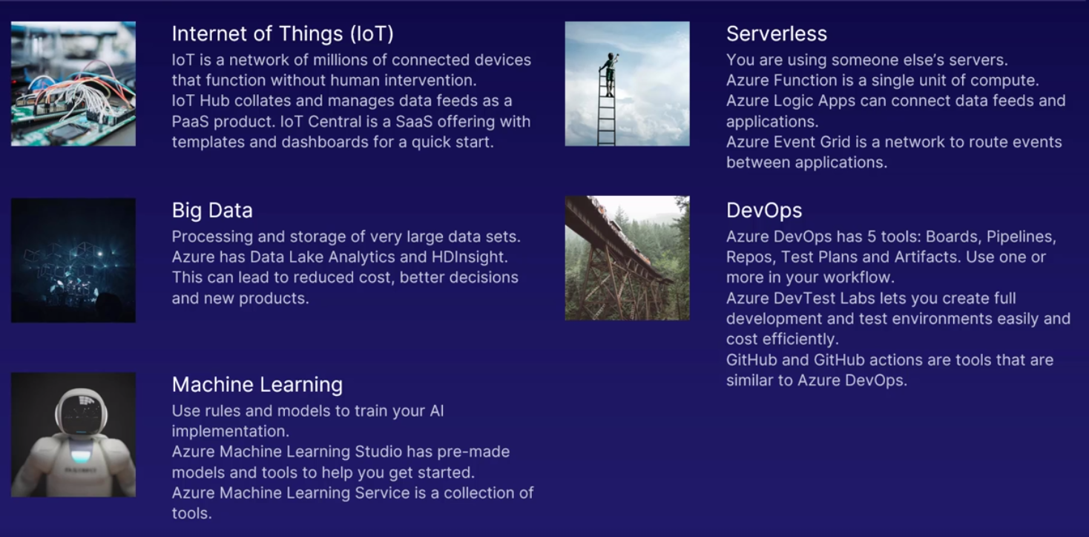

## Chapter 10 – Security

* C 10.2 – Defence in Depth
  + AZ Defence Layers
    - Physical
      * AZ’s servers
    - IAM
    - Perimeter (protection against DDoS)
    - Network Security/Filter (NSG)
    - Compute (protects DB and VMs)
    - App Gateways/Firewalls
    - Encrypted Data
* C 10.3 – Securing Network Connection
  + AZ Firewalls
    - rules for Internet Traffic (incoming)
    - Diff variations of Firewalls
    - Critical Part!
  + Distributed Denial of Service Attacks (DdoS)
    - Many Computers **overwhelm** a web server w/ requests until it crashes
    - Protection (detect DDoS then deflect)
    - No downtime
  + NSGs
    - networking/IP resource Firewall (attach to Vnets, Subets, Network Interface
    - rules to what can interact with the resources
      * ex. VM w/ NSG
  + App Security Group
    - protects app infrastructure (ex. Website or Web app)
      * focused on app
    - Natural Extension
      * group Vms/Vnets into logical app groups
* C 10.4 – AZ Security Centre
  + Shows:
    - Threat Alerts
    - Setup for Hybrid cloud
    - Each VM has an agent that sends data to AZ Security Centre
  + Highlights in AZ SC
    - Policy and compliance metrics
    - Secure Score
    - Integrate with other cloud providers
    - Alerts insecure resources
  + Using Az SC
    - Define policies to monitor resources
    - Protect resources (you actively monitor)
    - Respond to AZ alerts
  + Regulatory compliance dashboard
    - assesses based on standards
  + Security Hygiene
    - how well your setup is good compared to Industry Standards
* C 10.5 – Key Vaults
  + place to store passwords and secrets
  + Features
    - Secure Hardware
    - App Isolation (only app can access what is defined)
    - Scales Globally
* C 10.6 – AZ Info Protection
  + sharing secure doc, emails, data outside company networking
    - Classify data by sensitivity level
    - Track activities of shared data-platforms
    - Control sharing data
    - Integrated with MS tools (ex. MS Office)
* C 10.7 – MS Defender for IAM
  + Functions:
    - Monitor Users (analyze user activity and info)
    - Creates Baseline of Normal Behavior
    - Suggests changes to meet security standards
  + Cyber-Attack Kill Chain
    - Defender alerts if someone is doing reconnaissance on secure data
    - Brute force attacks are flagged
    - Alerts when user is trying to gain more privileges
* C 10.8 – AZ Sentinel (Security Info and Event Management (SIEM) tool)
  + - How?
      * Data collection
      * Aggregate and normalizes data
      * Analysis and Threat Detect
      * Take action
    - Features
      * Behavioural Analytics
      * AWS Integrated too
      * Cloud Scale (based on need)
* C 10.9 – AZ Dedicated Hosts
  + Hardware Control (total control of physical server)
  + You Control
    - physical layer isolation --> no foreign VMs on your host
  + Control over maintenance schedule
  + Benefits
    - Compliance
    - Global Infrastructure
    - OS of your choice
* Summary
  + 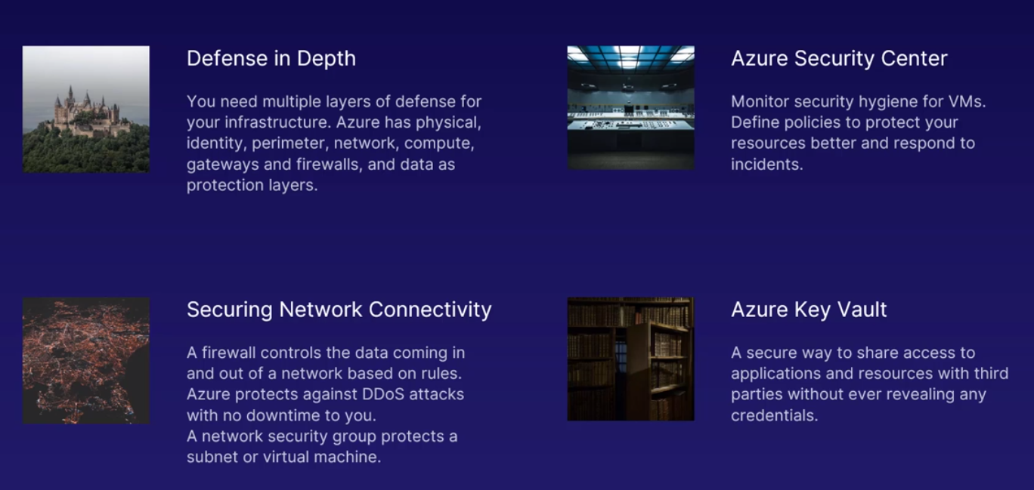
  + 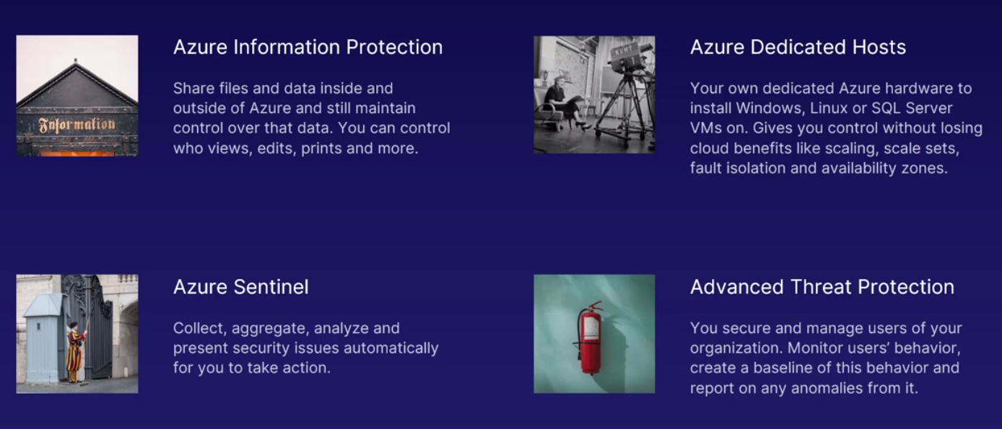

Chapter 11 – Privacy, Compliance, Trust

* C 11.2 – AZ Governance
  + Tools
    - AZ Policy
      * set of rules that standards are followed/compliant resources
        + ensures that resources are compliant
      * **Role-based Access Control** (RBAC)
        + Defines User Access and abilities
        + Minimum Access of users
        + Target specific user cases

assigns permissions based on this

* + - * + Role Assignment:

3 Elements

Security Principal

object reps what type of entity gets access to

Role definitions (list of permissions)

Scope (what role applies to which subscription)

* + - Locks
      * assigned to sub, RGP, resources
      * 2 Types
        + Delete (prevents)
        + Read-only
        + Locked means locked

lock must be removed before the locked actions can be performed again

* + Users and Resources
    - Tools:
      * AZ Blueprints
        + templates for making AZ resources

contains:

resource template

RBAC

Policies

samples for common scenarios

* + - * Cloud Adoption Framework
        + collection of documents that guide through cloud adoption process
        + guidance on:

making strategies for adoption

planning move, managing move

governance practices

* + - * + Governance
      * AZ Advisor for Security Assistance
        + in AZ SC
  + Summary:
  + 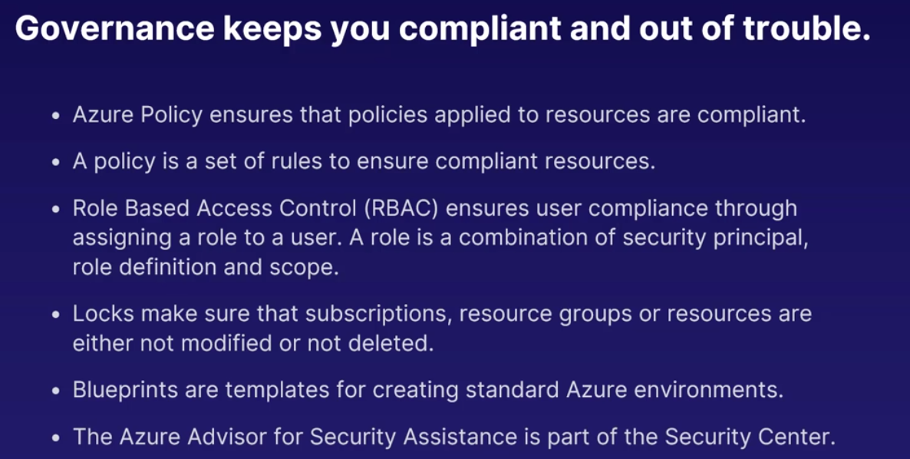
* C 11.3 – AZ Monitor
  + finds resources that aren’t performing at 100%
    - * Telemetry
      * info on how devices/resources are performing
  + **Goal of Monitor is:**
    - Maximize performance and Availability
    - By identifying issues
  + **Monitor will**:
    - Constantly consume telemetry data from resources
    - Fully Manage Telemtric data centrally
    - Query language to view data
    - Machine learning to recognize/predict problems
* C 11.4 – AZ Service Health dashboard
  + notifies of planned/unplanned issues
    - Features:
      * Dashboard
        + shows service issues
      * Custom Alerts (planned and non-planned outages)
      * Real-Time Tracking of Issues
      * Free service
* C 11.5 – Compliance
  + Industry Regulations/Compliance
    - 3 Types:
      * General Data Protection Regulations
        + objective = protect individuals’ data
        + ensures personal data is not owned by company
      * ISO Standard
        + quality/CX satisfaction
      * NIST
        + solely for tech industry security

ex. Cyber-security framework

* + Tools
    - AZ Compliance Manager
      * gives recommendations
      * Benefits:
        + recommendations given
        + assign compliance tasks
        + compliance score
        + secure storage of Compliance Documents
        + reports
  + AZ Regions and Offerings
    - AZ Government Cloud
      * Dedicated separate data-centres
        + requires specific compliance standards
      * Exclusivity
      * Compliance for all government standards
      * AZ Benefits
    - China Region
      * Data centres are located in China
      * Data is kept in China
      * Compliant to Chinese regulations
  + Summary
    - 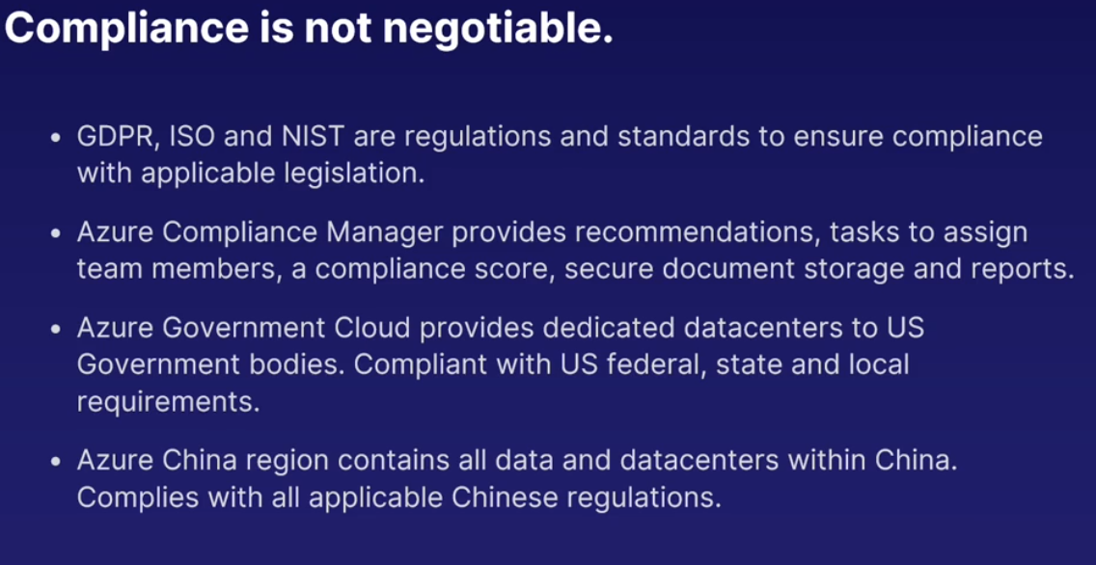
* C 11.6 – Privacy
  + Tools and services:
    - AZ Info Protection
      * classify, label, protect data based on sensitivity
    - AZ Policy
      * ensure privacy/regulations
    - Guides for compliance
    - AZ Compliance Manager
* C 11.7 – Trust
  + AZ Trust Centre
    - Info hub for MS’s security/privacy
  + AZ Service Trust Portal
    - review Azure audits/reports
* Summary
  + 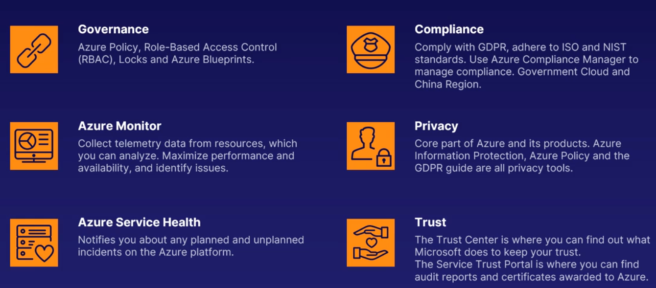

## Chapter 12 – Pricing

* Intro:
  + Pay for hours you use and to add more resources
    - Service Payment is tiered and Location changes costs
* C 12.2 – **Subscriptions** * all resources exist on subscription
  + Features:
    - Multiple Subscriptions
      * 1 AZ account : multiple subscriptions
    - Billing Admin (owned by 1+ users)
      * manages all billing and invoicing on AZ
    - Billing cycle (30-60 days)
  + Offer Types (type of sub)
    - ex. Enterprise, Pay-as-you-go, free trial, etc.
  + Management Groups
    - group subscriptions by use
    - organize
      * manage access, policies, and compliance in bulk
    - billing logic
      * **ex**. nest management by relationship
* C 12. 3 – AZ Cost Management
  + buy services from AZ
  + Free Accounts
  + **AZ Portal Dashboard**
    - views of current and projected costs
    - reports/recommendations for cost savings
    - optimization information to save money
  + Spot Pricing
    - Benefits:
      * “deep discounts” --> spot VMs
      * save up to 90% of price
    - Spot VM
      * save money by using unused capacity
      * but! Spot VMs can be removed by AZ at any time
      * use for non-critical workloads
      * use with AZ scale sets
      * set a max price for the Spot VM
* C 12.4 – Pricing factors
  + Influences on Price
    - Size of the resource (ex. Stronger VM = higher price)
    - Type of the resource (complexity of the resource)
    - Location of service
    - Bandwidth needed for services
      * **3 Billing Zones/Bandwidth**
        + data transfer between billing zone is not free
        + data transfer within billing zone is free

Ingress (data in)

Egress (data out)

* + AZ Pricing Calculator
    - monthly estimates (use as a report) for resources
  + AZ Total Cost of Ownership Calculator
    - total savings by using Azure vs. On-Premise
* C 12.5 – Best Practices
  + **Spending** **limits**
    - Default limit (monthly credits) --> limit kicks in and stops resource
    - No increase in the limit as you go (need to remove it completely at the end of the payment period)
    - No Spending limit (pay as you go)
  + **Quotas**
    - Property limit
      * ex. 100 namespaces for Event Hub
    - Quotas ensures AZ’s high service level
    - Quota change if you as AZ
  + **Tags**
    - non-functional label you can attach to resource or RGP
    - Best Practices with Tags
      * Identify roles that can access a resources
      * Related resources
        + defining which resources are related helps with bulk processing and updating
      * Filter resources by project or reporting
      * Unambiguous tags
        + ex. Description, tag name, values of each tag
  + Pay as you go = expensive!
  + Tools to Save Cash:
    - Reserved instances help save cash
      * not available for all resources
    - Reserved Capacity
      * 1-3 year commitment
      * Available to:
        + AZ SQL (80% saving...)
        + CosmosDB (65%)
        + Synapse Analytics (65%)
        + Redis Cache (55%)
    - AZ Hybrid Benefit
      * save on VMs and SQL servers
      * use existing licenses you have
    - AZ Advisor
      * gives recommendations to save
      * ex. storage that is dormant
* Summary
  + 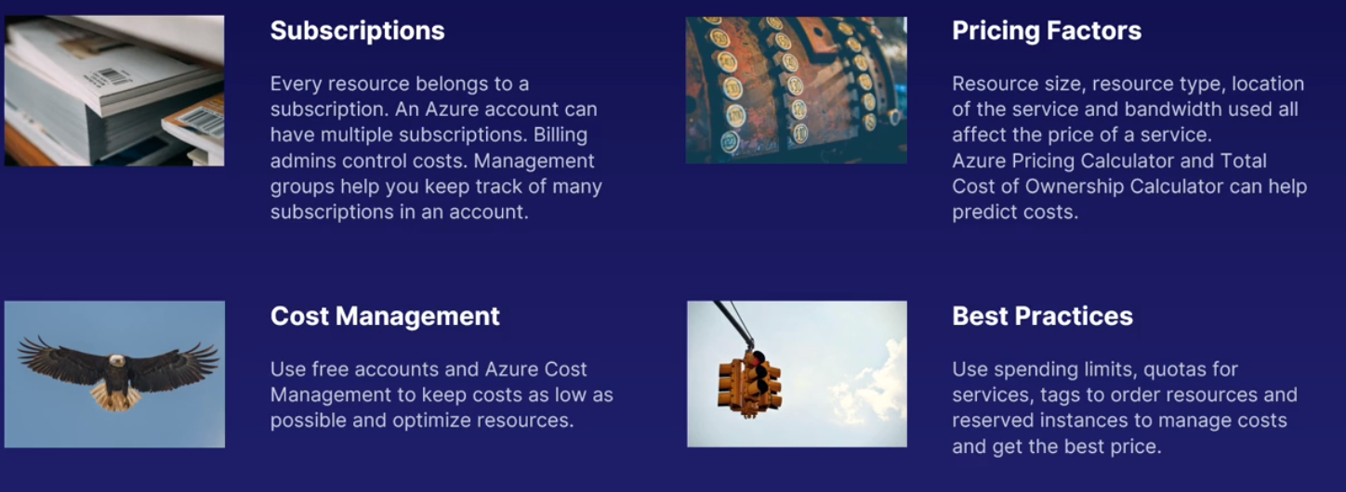

## Chapter 13 – AZ Support

* C 13.2 – Support Plans
  + 5 Types of Support Plans (cost and support)
    - Basic
    - Developer
    - Standards
    - Pro Direct
    - Premier
  + All Plans have this:
    - 24/7 Access to billing and subscription support
    - Online Self-help and Documentation
    - Forums
    - Azure Advisor for recommendations
    - Service Health statuses on issues and maintenance
  + Paid Plan Features:
    - 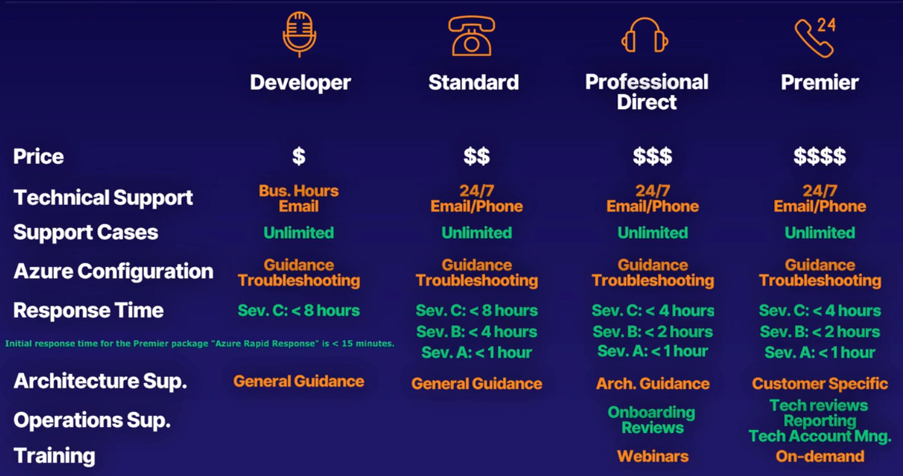
* C 13.3 – Tickets
  + support inquiries (unique id of request) – single reference
  + submit through portal
    - choose 4 support ticket tpes
    - fill in details
    - request is processed according to support plan
* C 13.4 – Channels
  + AZ documentation by PMs and community
  + Forums for questions
  + Social Media (can get direct support)
* C 13.5 – AZ on Q&A
  + answers common questions
    - No new questions
    - Search existing questions
    - Complements other channels
* C 13.6 – Service Level Agreements (SLA) --> agreement between company and you
  + **ensures**:
    - Confidence in uptime and reliability of services
    - Contract that MS will commit for uptime and connectivity
    - SLA per product
    - Complex and varies by level, region, services
    - Mandatory to have a SLA
    - Improve SLA
* C 13.7 – Service/product Lifecycle
  + CX provides Customer feedback/data
  + Stages:
    - Preview
      * Private preview (only certain users can test and use the service) --> evaluations
      * Public preview (all cx can test and evaluate)
    - General Availability
      * all cx can use it w/ SLA
      * service is generally available
      * gradual roll-out by Product Team
* Summary:
  + 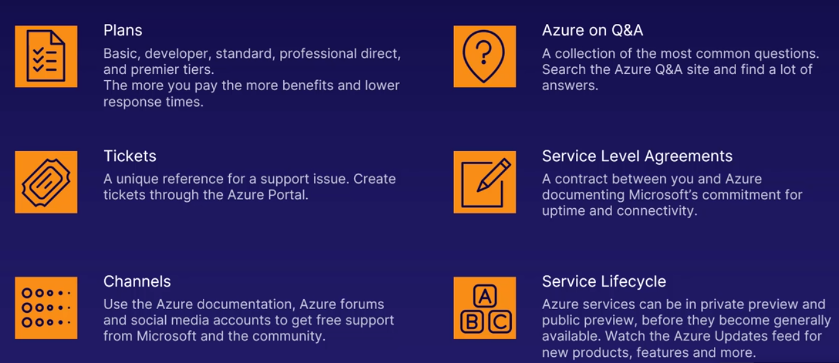

## Exam Preparation

* Overview
  + 60 Minutes
  + 44 Questions
  + Types of Qs
    - M/C
    - Statement (correct or not), swap if wrong
    - Drag and drop
    - Hotspot areas (click right area)
    - 3 Q’s, once answered, can’t go back, true or false
  + 6 Parts:
    - Describe Cloud Concepts (c. 2) – 20-25%
    - Describe Core AZ Services (c. 3-7) – 15-20%
    - Describe Core Solutions and Management Tools on AZ (c. 1, 9, 11) – 10-15%
    - Describe General Security and Network Security Features (c. 10) – 10-15%
    - Describe Identity, Governance, Privacy, and Compliance Features (c. 8, 11) – 20-25%
    - Describe AZ Cost Management and SLAs (c. 12-13) – 10-15%
  + 700/1000 points to pass